**Credit scoring models**

Credit scoring models are statistical tools used by lenders to evaluate the creditworthiness of individuals and businesses. These models analyze various factors to predict the likelihood that a borrower will default on their debt.

3 ways

* Expert opinion
* Statistical model- automated
* Hybrid model (combination of both)

There are some websites where we can know our credit score by uploading our data

**Argos-dcb**

**Credit officers or credit scoring administrators**

**We can upload our data only in excel sheet form which must contain a historical data of loans (repayment of loan data)**

**We can predict our loan probability’**

**Higher the expert score higher the chance for loan**

**We also have an option of choosing between the expert and statistical methods weightage.**

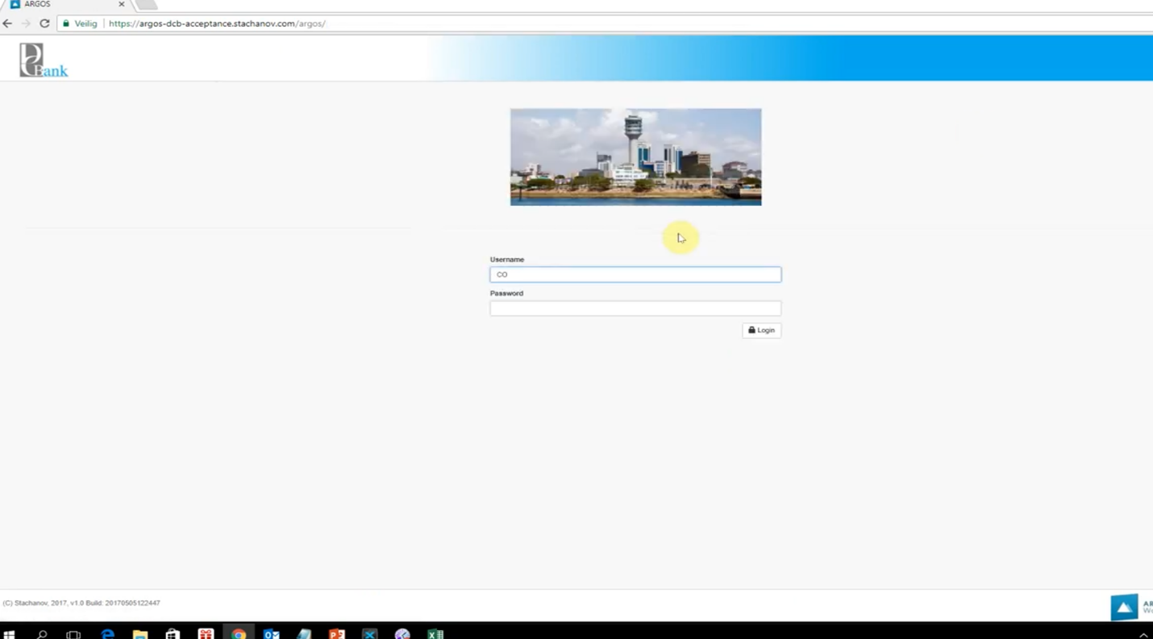

**Types of Credit Scoring Models**

1. **FICO Score**
   * **Developer**: Fair Isaac Corporation (FICO)
   * **Scale**: 300 to 850
   * **Factors Considered**:
     + Payment history (35%)
     + Amounts owed (30%)
     + Length of credit history (15%)
     + New credit (10%)
     + Credit mix (10%)
   * **Usage**: Widely used by lenders in the U.S. for personal credit evaluation.
2. **Vantage Score**
   * **Developers**: Equifax, Experian, and TransUnion
   * **Scale**: 300 to 850
   * **Factors Considered**:
     + Payment history (40%)
     + Age and type of credit (21%)
     + Percentage of credit limit used (20%)
     + Total balances/debt (11%)
     + Recent credit behavior and inquiries (5%)
     + Available credit (3%)
   * **Usage**: Increasingly used as an alternative to the FICO score.
3. **Internal Bank Scoring Models**
   * **Developers**: Individual financial institutions
   * **Factors Considered**: Custom factors based on the bank's lending criteria and customer data.
   * **Usage**: Used by banks to assess the credit risk of their customers, often in conjunction with FICO or Vantage Score.
4. **Behavioral Scoring Models**
   * **Factors Considered**: Customer behavior such as transaction patterns, account usage, and other non-traditional data.
   * **Usage**: Often used by fintech companies and some progressive financial institutions to assess credit risk more dynamically.
5. **Custom Scoring Models**
   * **Developers**: Credit bureaus or specialized firms
   * **Factors Considered**: Specific to the lender's requirements, may include traditional credit factors, as well as alternative data such as utility payments, rental history, and social media activity.
   * **Usage**: Tailored to specific lending products or customer segments.

**Key Features and Components**

1. **Payment History**:
   * The record of on-time, late, or missed payments. A critical component in most credit scoring models.
2. **Credit Utilization**:
   * The ratio of current credit balances to credit limits. High utilization can indicate higher risk.
3. **Length of Credit History**:
   * The duration of the borrower's credit history. Longer histories are typically viewed more favorably.
4. **Types of Credit**:
   * The diversity of credit accounts, including credit cards, mortgages, and installment loans.
5. **Recent Credit Activity**:
   * Recent applications for new credit and the opening of new accounts. Multiple recent inquiries can be seen as risky.
6. **Debt Levels**:
   * The total amount of debt currently owed by the borrower.

**Advanced Techniques**

1. **Machine Learning Models**:
   * Use algorithms to identify complex patterns in large datasets. Can incorporate a wide range of traditional and alternative data sources.
   * Examples: Gradient boosting, neural networks, random forests.
2. **Alternative Data Models**:
   * Incorporate non-traditional data such as social media activity, mobile phone usage, and utility payments.
   * Aimed at providing credit scores for individuals with limited or no traditional credit history.

**Applications**

1. **Loan Approval**:
   * Determines whether a borrower qualifies for a loan and the terms of the loan (interest rates, credit limits).
2. **Credit Limit Adjustments**:
   * Used by credit card companies to adjust credit limits based on updated credit scores.
3. **Risk Management**:
   * Helps lenders manage risk by identifying high-risk borrowers and adjusting lending strategies accordingly.
4. **Marketing**:
   * Identifies potential customers for pre-approved credit offers.

Credit scoring models are essential tools in modern finance, helping lenders make informed decisions and manage risk effectively.